Final Project Design Phase
Computer Science - Week 11
Oct 3, 2026 - Version 0.0.4

For complete instructions and project ideas, refer to the assignment in Canvas. Specifically, review the final project requirements before you continue below. If you have not reviewed the project requirements in Canvas (you might have to go to the modules view and check the current or past week's content), you will not be able to properly complete the parts below. In addition, it may be helpful to review the information on this Drafter documentation page.

0) Project Planning and Preparation
Successful programmers spend time planning before they begin coding. After reviewing the project requirements, answer the following questions to help guide your design and development process.
- What concepts from class or previous assignments might help you complete this project? Which programming concepts (loops, conditionals, lists, classes, etc.) do you expect to use? What programming skills do you want to improve while completing this project?
I think conditionals will be very helpful to ensure the type of data that the user inputs is correct.

- Which parts of the project do you expect to be the easiest for you? The hardest? Why?
I think the easiest will be coding the formulas, but I think I will have trouble putting the user input into the formula.

- Even though you have not yet designed the final project, estimate which tasks will likely require the most time and effort? Which features or components should be implemented first?
I think the drafter code and route will be the most complicated component for me. To start my project I will define the dataclasses and work from there.

- What distractions might interfere with your work and how will you minimize them? What resources will you need available while working? What questions, if any, do you still have about the assignment requirements?
I think the other classwork we have will distract me.

1) Site Diagram
Create a mock-up of your planned website. We suggest you make the mockup on paper, although you can also use software like PowerPoint or Slides to make a mockup. There is other design software that could also be used, but we strongly encourage you to keep it simple. Do not spend more than 15-30 minutes detailing the mock-up. Your goal should be to make a very quick and dirty diagram, to show that you have some kind of idea.

We recommend drawing each page as a rectangle, and laying out the text, buttons, and other components inside. Then, use arrows to indicate links between pages. Label each page the way you will name each function, and then put labels on the arrows to indicate what the button links. Also write down any parameters that should come into the pages.

In addition to the pages and routes, write down what fields your `State` will have, both their names and types. Think clearly about what data will need to be persistent across the entire website.

Add photo(s) or screenshot(s) of your website mock-up and labeled diagram on the next page.
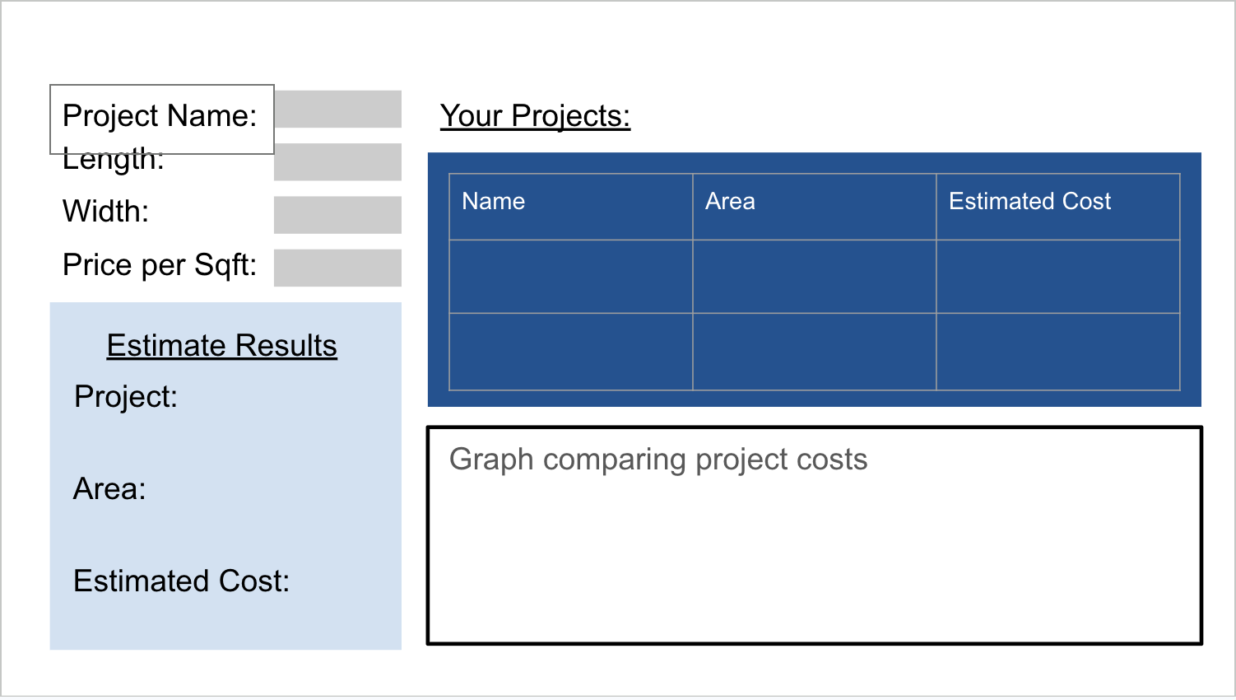

2) Implementing Requirements
This table should serve as a draft for how you will implement the requirements into your final project. You may change your ideas later on, but your final site must fulfill all the requirements.

Requirement | Implementation
Purpose/Functionality  A 1-2 sentence description of the purpose or functionality of your site | To easily calculate the cost of paving a small area, and to compare the costs of different projects.
State Dataclass Attributes  Minimum of 4 attributes, one of which must be a list/dict of instances of your second dataclass.  Briefly describe each attribute, its type, and how it will be meaningfully modified throughout the site. | Class State:  - estimates: list[PavingProjects] -> modified when a new estimate is saved  - Current_estimate: PavingProjects  - Project_name: str -> user input  - Length: str -> user input  - Width: str -> user input  - Price: str -> user input  Bottom 4 are modified when the user enters new information.
Second Dataclass  Your second dataclass, including its attributes, their types, and how they will be meaningfully modified (if they are modified) | Class PavingProjects:  - Name: str  - Length: float  - Width: float  - Price: float  - Estimated_cost: float
Routes (minimum 7)  The names of your route functions | Home_page, new_estmate_page, calculate_estimate, estimates_page, estimate_details_page, compare_estimates_page, reset_estimates
Pages (minimum 5)  A brief description of the pages in your site | Home - Welcome page with brief directions  New Estimate - where a user can input length, width, price, and name  Project Results - shows a list of the projects entered while the website has been open  Details - gives the details on each project  Compare - graph comparing the estimated cost of different projects
User Input (minimum 3)  Description of user input components (TextBox, TextArea, CheckBox, or SelectBox) and their purposes  For more information on these input types, see Drafter Documentation. | Length, width, price, and name textboxes
If Statements (minimum 3)  Brief description of what will be evaluated in your if statements and how they will meaningfully change the logic of the site | Validate the input, check if a project exists, ensure theres enough projects to compare (at least 2).
Loop (minimum 1)  This loop must iterate over the list/dict of dataclass instances in your State attribute.  Description of this loop and why it is meaningful to the site | Looping through state.projects to display project information.

LLM Conversation
If you used an LLM in any part of this work, copy and paste every part of that conversation below. Otherwise, you may be given a zero for the assignment. Obviously, these words will not all be yours, and this is the exception to the requirement at the top of this assignment that all responses be in your own words. If you did not use an LLM to assist you in this assignment, simply say so below.
Use the following info to explain the dataclasses I need if my website does not store information for longer than when it is open.
“State Dataclass Attributes
Minimum of 4 attributes, one of which must be a list/dict of instances of your second dataclass.
Briefly describe each attribute, its type, and how it will be meaningfully modified throughout the site.Second Dataclass
Your second dataclass, including its attributes, their types, and how they will be meaningfully modified (if they are modified)”
Great—your estimates will be stored in memory only while the app is running. They won’t be saved to a database or browser storage, and they’ll disappear when the app restarts or refreshes.

State Dataclass Attributes
Attribute | Type | Description and how it will be modified
estimates | list[PavingProject] | Holds estimates created during the current app session. Estimates are added when the user calculates and saves one, and removed when the user deletes one.
project_name | str | Stores the name entered for the current estimate.
length | str | Stores the entered project length in feet.
width | str | Stores the entered project width in feet.
price_per_sqft | str | Stores the entered estimated price per square foot.
current_estimate | PavingProject \| None | Holds the estimate currently being viewed. It changes when the user calculates or selects an estimate.

Second Dataclass: PavingProject
Attribute | Type | Description
name | str | Name of the paving project.
length | float | Project length in feet.
width | float | Project width in feet.
price_per_sqft | float | Estimated price per square foot.
estimated_cost | float | Estimated total cost, calculated using length × width × price per square foot.

Example code
@dataclassclass PavingProject: name: str length: float width: float price_per_sqft: float estimated_cost: float@dataclassclass State: estimates: list[PavingProject] project_name: str length: str width: str price_per_sqft: str current_estimate: PavingProject | None
This meets the requirement because State has at least 4 attributes, including estimates, a list of instances of the second dataclass. The list is modified by adding and deleting estimates during the session.

Final Submission
When you are finished, download this file as a Word Document (docx) and upload the file to the appropriate assignment on Canvas.

